Erwin Seguinte

February 14, 2017

CSC 165

Assignment 1

To start the game please just use the “Start.bat”. This batch file runs the command:

java -jar -Dsun.java2d.d3d=false "a2.jar”

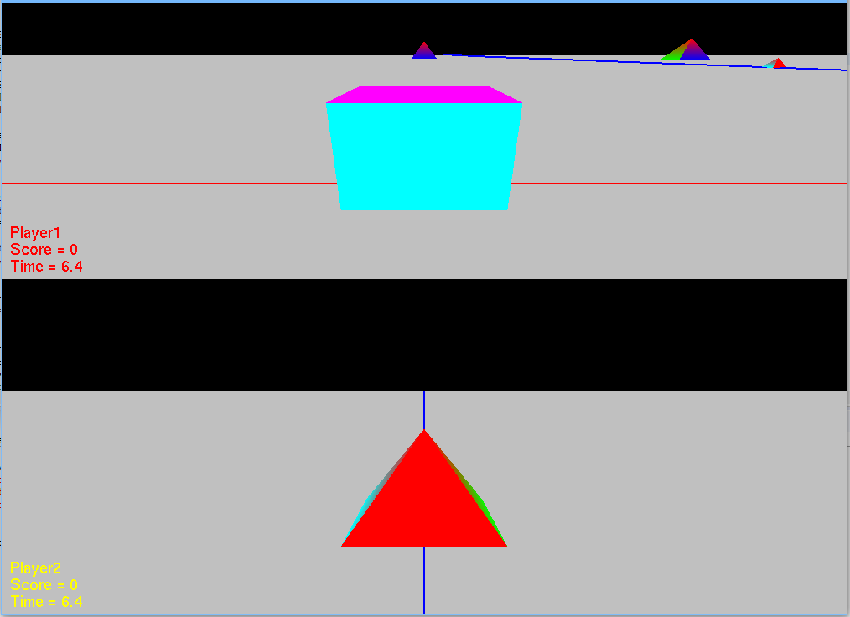

The game controls are:

Player 1

* + W: Forward Movement
  + S: Backward Movement
  + A: Left Movement
  + D: Right Movement
  + Arrow Up: Forward Zoom
  + Arrow Down: Backwards Zoom
  + Arrow Left Orbit
  + Arrow Right: Right Orbit

Player 2

* + Left Joystick X-Axis: Movement Left and Right
  + Left Joystick Y-Axis: Movement Up and Down
  + Right Joystick RX-Axis: Left and Right Orbit
  + Right Joystick RY-Axis: Upward and Downward Zoom

When the camera collides with a plant (Pyramids) the score goes up by one and the plant moves into the truck.

Game Requirements:

* A third person orbit camera was implemented. When moving, the camera left or right it orbits the target
* There are two players in the game that have independent cameras
* There is a grey ground plane
* Each player has a HUD showing name, points, and time
* The plants grow and shrink over time and they move up and down
  + I have a translation and scale controller
* Player 1 uses the keyboard and player 2 uses a Gamepad
* The plants are all in one Scene Group and are using both node controllers
* InitGame(), update(), initSystem and render were overwritten
* The game plays is FSEM
* Plants still respond to events

This was tested using an Xbox One Controller and was tested on PONG